**Part 1： Bootstrapping Swap Curves**

**i)**

For the fed rate and OIS discount of first year:

$${OIS}_{1y}={\left(1+\frac{f_{0} }{360}\right)}^{(1*360)}-1$$

$$\text{OIS Discount(0,1y) }=\frac{1}{{\left(1+\frac{f_{0} }{360}\right)}^{(1*360)}}$$

For the fed rate and OIS discount of the next years:

$$D_{o}\left(0,T_{n}\right)=D_{o}\left(0,T_{n-1}\right)*\frac{1}{{\left(1+\frac{f_{n}}{360}\right)}^{360}} ①$$

$$IRS\left(0,T_{i}\right)*\sum_{n=0.5}^{i}{ }D_{o}\left(0,T_{n}\right) =\sum_{n=0.5}^{i}{ }D_{o}\left(0,T_{n}\right)*\left({\left(1+\frac{f_{n}}{360}\right)}^{360}-1\right) ②$$

We use equation 1 to replace $D_{o}\left(0,T_{i}\right)$ in equation 2 so that equation 2 has only one unknown $f_{i}$.

When the OIS rate of some tenors is unknown, we can use linear interpolation on OIS discount factor to eliminate the unknowns:

$D_{o}\left(0,T_{n}\right)=D_{o}\left(0,T_{n+i}\right)+\frac{i}{i+j}*\left(D_{o}\left(0,T_{n-j}\right)-D_{o}\left(0,T_{n+i}\right)\right), D_{o}\left(0,T_{n-j}\right) is known.$

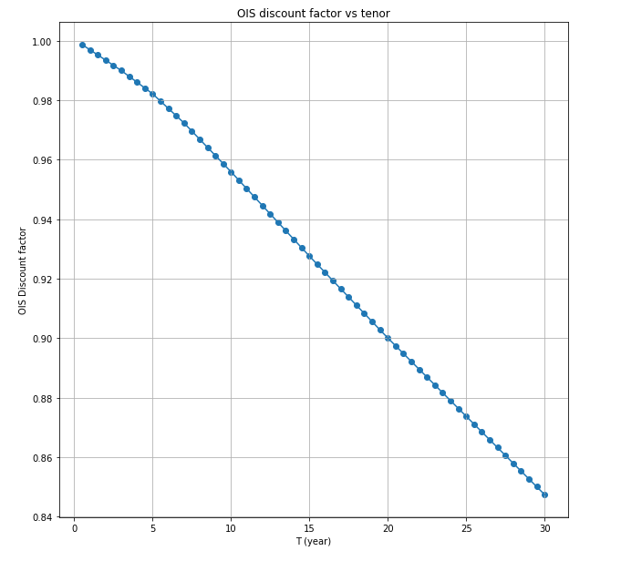

**ii)**

The approach of question 2 is similar to the one of question 1. For the first tenor (0,0.5y):

$$D_{L}(0,0.5y)=\frac{1}{1+0.5*L(0,0.5y)}$$

For the next tenors:

$$L\left(T_{n-1},T_{n}\right)=\frac{D_{L}\left(0,T_{n-1}\right)-D_{L}\left(0,T_{n}\right)}{Δ*D_{L}\left(0,T_{n}\right)} ①$$

$$0.5*IRS\left(0,T_{i}\right)*\sum_{n=0.5}^{i}{ }D_{o}\left(0,T_{n}\right)= 0.5*\sum_{n=0.5}^{i}{ }D_{o}\left(0,T_{n}\right)*L\left(T_{n-1},T_{n}\right) ②$$

Use equation 1 to replace $L\left(T_{n-1},T_{n}\right)$ in equation 2 so that equation 2 has only one unknown $D_{L}\left(0,T_{n}\right)$.

When the IRS rate of some tenor is unknown, we still use linear interpolation on LIBOR discount factor:

$D_{L}\left(0,T_{n}\right)=D_{L}\left(0,T_{n+i}\right)+\frac{i}{i+j}*\left(D_{L}\left(0,T_{n-j}\right)-D_{L}\left(0,T_{n+i}\right)\right)$, $D_{L}\left(0,T_{n-j}\right) is known$.

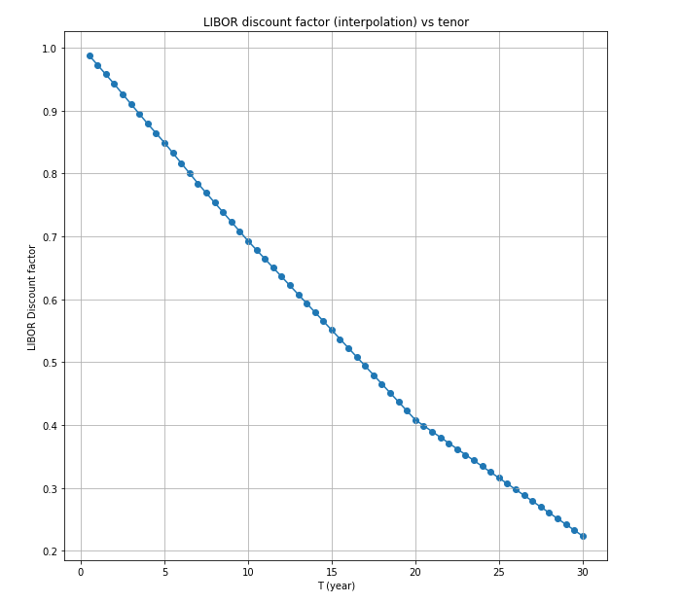

**iii)**

$$0.5*S\left(T_{i},T_{i+m}\right)*\sum_{n=i}^{i+m}{ }D_{o}\left(0,T_{n}\right)= 0.5*\sum_{n=i}^{i+m}{ }D_{o}\left(0,T_{n}\right)*L\left(T_{n-0.5},T_{n}\right)$$

In this equation, the only unknown is $S\left(T_{i},T_{i+m}\right)$.Then we transform the equation:

$$S\left(T_{i},T_{i+m}\right)=\frac{0.5*\sum_{n=i}^{i+m}{ }D_{o}\left(0,T_{n}\right)*L\left(T_{n-0.5},T_{n}\right)}{0.5*\sum_{n=i}^{i+m}{ }D_{o}\left(0,T_{n}\right)}$$

|  |  |  |  |
| --- | --- | --- | --- |
|  | Expiry | Tenor | Swap_Rate |
| 0 | 1Y | 1Y | 0.032007 |
| 1 | 1Y | 2Y | 0.033259 |
| 2 | 1Y | 3Y | 0.034011 |
| 3 | 1Y | 5Y | 0.035255 |
| 4 | 1Y | 10Y | 0.038428 |
| 5 | 5Y | 1Y | 0.039274 |
| 6 | 5Y | 2Y | 0.040075 |
| 7 | 5Y | 3Y | 0.040072 |
| 8 | 5Y | 5Y | 0.041093 |
| 9 | 5Y | 10Y | 0.043634 |
| 10 | 10Y | 1Y | 0.042189 |
| 11 | 10Y | 2Y | 0.043116 |
| 12 | 10Y | 3Y | 0.044097 |
| 13 | 10Y | 5Y | 0.046249 |
| 14 | 10Y | 10Y | 0.053458 |